Talal Jawaid

11/12/19

CSC 139

Homework 2

1. Identify the race contidition.

Race condition is based on the continuously changing number of processes (number_of_processes)

* 1. Acquire() after declaring new_pid int.
  2. Release() in first if statement
  3. Release() after incrementing num of processes
  4. Acquire() before decrementing num of processes
  5. Release() after decrementing num of processes  
       
     A screenshot of a cell phone

     Description automatically generated

1. T2, T3, T4, T0, T1  
   
2. Request can be granted immediately.  
   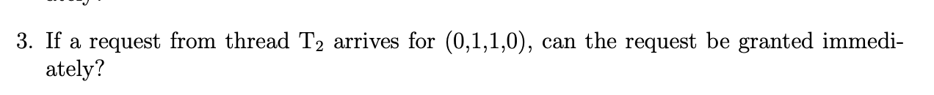
3. Request can be granted immediately  
   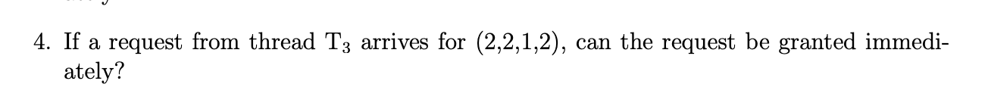
4. Request can be granted immediately.   
     
   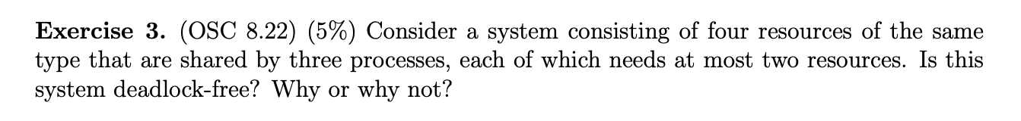
5. System is deadlock free because each process only needs at MOST two other resources, which means that since there are four resources, two processes will be able to complete at same time meaning that there is no deadlock.  
   A close up of a logo

   Description automatically generated
6. System can be in an unsafe state that can potentially result in a deadlock for example, if there is a number of resources that are available that are currently unused, but then if a process calls all the resources, then system will be in a deadlock.   
   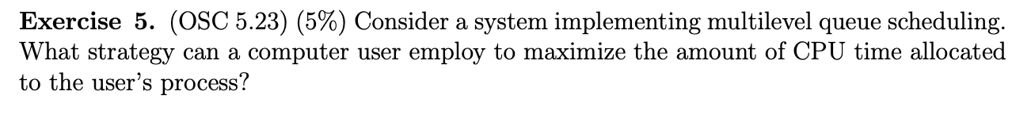
7. If the system manipulates the priority level of the process, it can be more efficient with CPU time for user processes. It could also switch before time quantum is complete if process is complete.   
     
   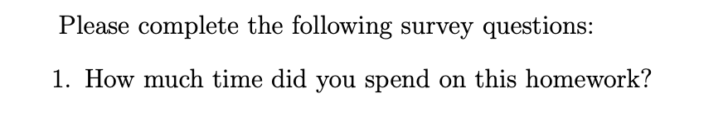
8. I spent about 4 hours on this homework, most time spent research however.  
   
9. I would rate this a 5  
   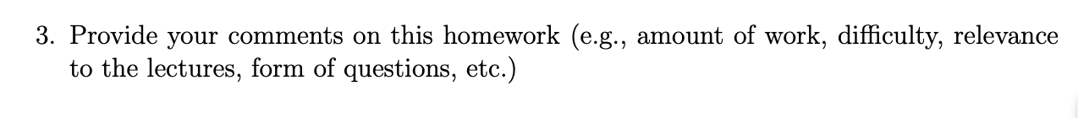
10. I hope test is easier than this